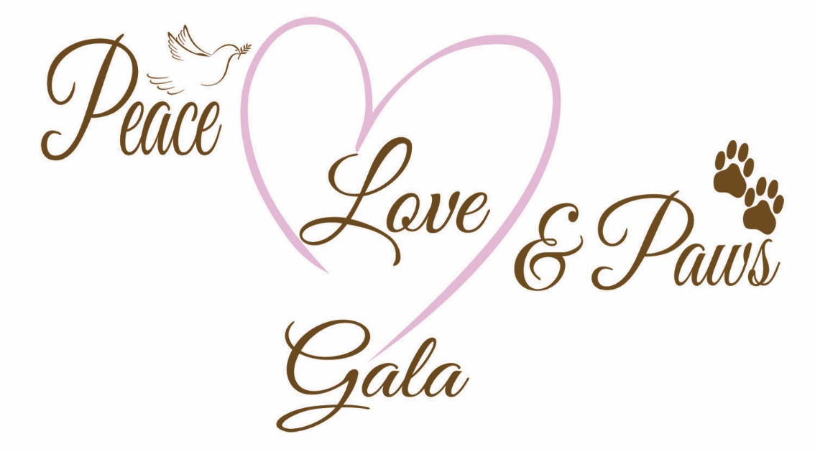
Caloosa Humane Society’s 20th Birthday Celebration
An Evening for the Animals

October 23, 2021
River Bend Motorcoach Resort
Prime Rib by Gator Hammock
Live Music by High Lonesome
Doors open at 5:00 pm

Silent Auction Live Auction Photo Booth
Tickets: $65 each/$125 for two
Sponsorships still available

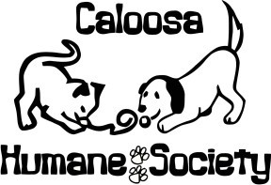
Tickets available at CHS
1200 Pratt Boulevard
LaBelle, FL 33935
or by phone at 863.675.0997

For more information contact Karla Kaufman 239.872.1892

