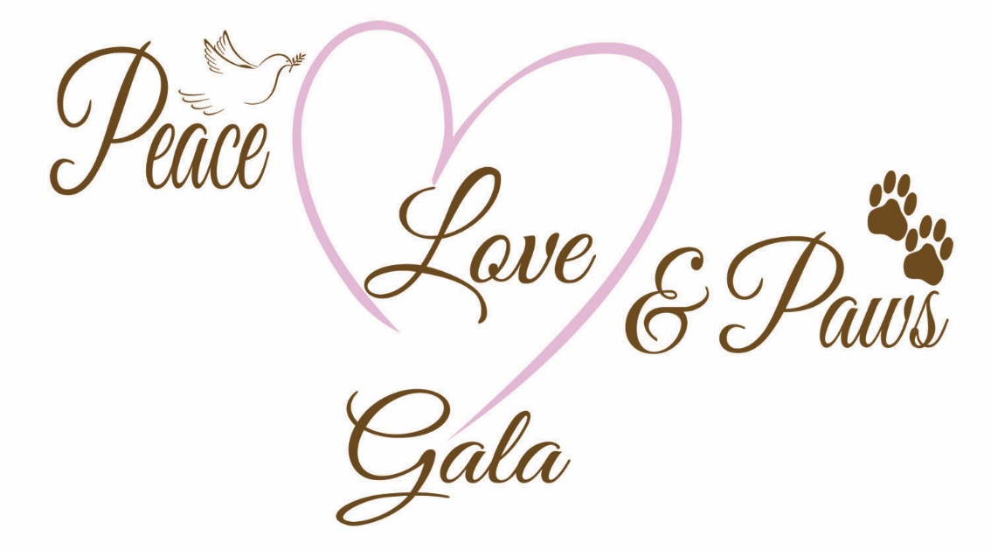
Caloosa Humane Society’s 13th Annual
An Evening for the Animals

November 5, 2022
River Bend Motorcoach Resort
Dinner by Gator Hammock
Live Music by High Lonesome
Free Beer and Wine
Doors open at 5:00 pm

Silent Auction Live Auction Photo Booth
Tickets: $80 each/$150 for two
Sponsorships still available

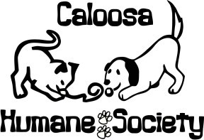
Tickets available at CHS
1200 Pratt Boulevard
LaBelle, FL 33935
or by phone at 863.675.0997

For more information contact Karla Kaufman 239.872.1892 or
Events@caloosahumanesociety.org

