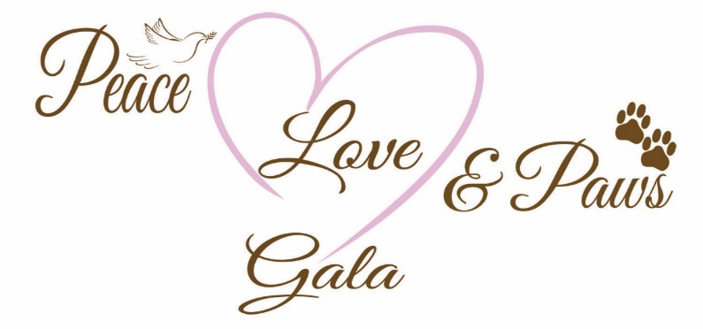
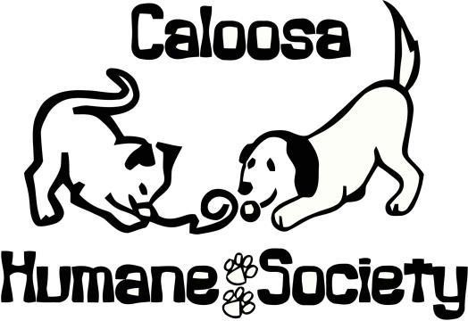
August 29, 2022

Dear Caloosa Humane Society Supporter,

The Caloosa Humane Society invites you to be a sponsor of the 13th Annual Peace Love & Paws Gala to be held Saturday, November 5, 2022 at 5 p.m. at the charming RiverBend Motorcoach Resort. The gala is a beautiful evening featuring a delicious dinner by Gator Hammock and live music by High Lonesome, a fantastic display of silent & live auction items, and other great ways to support our no-kill pet shelter. All funds raised go directly to support over 1,000 animals placed in our care each year.

As a non-profit organization, we are still completely reliant upon fundraisers and donations from our supporters in order to fulfill our mission to serve, shelter, and protect the homeless animals in our care. We are dedicated to finding permanent and loving adoptive homes for our companion animals in need. As a no kill shelter we also provide low cost spay/neuter services to the community with the goal of reducing the extreme overpopulation of unwanted animals.

Please help us and become a sponsor of this year’s Peace Love & Paws Gala! Your generosity allows us to continue our wonderful progress in helping the homeless pets of our community and beyond. We will also gladly accept items for our silent/live auctions.

Please respond to us by October 14, 2022, as that will be the deadline for all printed materials, and we wish to ensure that yours is included. Thank you!

If you have any questions at all, please do not hesitate to contact me either by phone 239-872-1892 or by email at: events@caloosahumanesociety.org.

Thanks again for your generous support of Caloosa Humane Society!

Sincerely,

Karla Kaufman
Peace Love & Paws Gala Chair
Board of Directors

Caloosa Humane Society
P.O. Box 2337 / LaBelle, FL 33975
863.675.0997 / caloosahumanesociety.org

